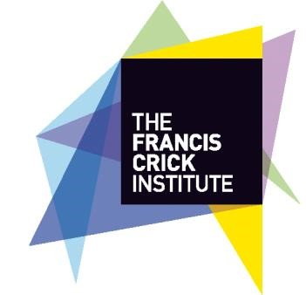

Introduction
The Francis Crick Institute is a world-leading centre of biomedical research and innovation in the heart of London. Our research will help understand why disease develops and find new ways to prevent and treat illnesses such as cancer, heart disease and stroke, infections, and neurodegenerative diseases such as Alzheimer’s.

To support our community engagement the Crick has set up a Community Chest to provide small grant funding to local community organisations/groups wishing to develop and run projects that help improve health and wellbeing.

Aims of the Community Chest scheme The Community Chest scheme aims to:

- help improve health and wellbeing in the local area
- help build local capacity
- raise awareness of the Crick and its mission
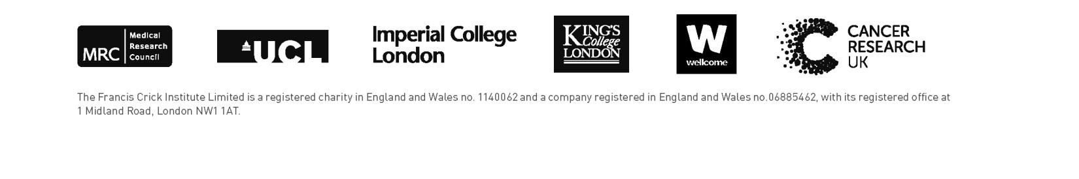
- help embed the Crick’s community engagement activity.

Scheme details
The Crick’s Community Chest will provide funding of up to £3,000 per award to local community organisations/groups wishing to develop and run projects that help improve health and wellbeing within a one-mile radius of the Institute.

In 2020-21 the Community Chest fund will be £21,000.

If your organisation/group wants to apply for funding, you will need to complete an application form. Your application will then be considered by the Crick’s applications panel. The panel meets twice a year (in May & November), though on occasions it may be possible to look at urgent applications for funding more quickly.

To be considered at the May panel, submit your application by Friday 1 May 2020.

For advice on completing the application form please contact the Crick’s Community Engagement
Manager on 020 379 63147 or engage@crick.ac.uk. You should send the completed form to Community Chest Applications, Public Engagement Team, The Francis Crick Institute, 1 Midland Road, London, NW1 1AT or to engage@crick.ac.uk.
The Crick will expect organisations/groups that are awarded funding to comply with a set of grant conditions (below), and to complete an evaluation of the funded project. This will help us award grants more effectively and identify future needs and opportunities.

Funding criteria
The Crick will judge applications on how well they meet one or more of the following criteria:

- improving the local community’s health and wellbeing
- improving opportunities for young people
- improving opportunities for older people
- encouraging/increasing community participation.

What the scheme will fund The scheme will fund:

- projects – funding to enable small-scale, innovative projects to be developed and run. The funding may cover salaries, revenue and capital costs, core administrative and other costs

- development – funding to enable a new group to develop its activities, or to build capacity to make an existing group more sustainable. This funding may cover investment in training, equipment etc.

Grants may be used to pay for the whole project or used with other funds where appropriate (match funding).

The Crick will not fund:

- applications which do not meet the funding criteria set out above
- general appeals for funding
- organisation/groups raising funds for central or national causes without a clear local focus and benefit
- individuals
- activities that promote a political party or religion, or groups seeking to alter decisions made by political parties
- retrospectively, or to reimburse expenditure already made or committed, or to clear debts or loans
- organisations/groups that have received two grants from the Crick’s community chest within the past three years.

Eligible organisation/groups
Social enterprises, not-for-profit, voluntary, or community organisations/groups based and actively working within a one-mile radius of the Crick’s offices at Brill Place, NW1 1HG, and in particular within the St Pancras and Somers Town ward.

Community organisations/groups applying for funding do not need to be registered charities. However, applicants should have a signed constitution or set of rules, and be able to provide documentation
that, as a minimum, covers the group name, aim or purpose, objectives and a list of Trustees/Committee members and their signatures.

Applicants should have a bank account in the name of the organisation/group. If the organisation/group does not have a bank account then it may still be possible to fund the organisation/group if it can find another group that will allow them to use its bank account. We will not pay funds into an individual’s bank account.

Conditions of grant
We will expect organisations/groups awarded funding to comply with the following conditions.

Your organisation/group must:

- use the grant only for the purpose set out in the organisation/group’s application and approved by the Crick

- comply with any relevant legislation that affects the project, e.g. health and safety, protection of children, adult safeguarding

- ensure that the planned activity does not discriminate on the grounds of gender, gender identity, race, religion or belief, sexual orientation, age, or disability

- unless otherwise agreed, acknowledge the Crick’s support in any marketing and publicity materials as appropriate. (You are under no obligation to use the Crick’s logo in any marketing and publicity materials, but if your organisation/group wants to use the logo you must follow the Crick’s brand guidelines and the Crick’s communications team must sign off material before it goes to print)

- complete a project evaluation form

- provide a set of annual accounts or an independently examined and evaluated financial statement within 9 months of the end of the financial year of grant funding, clearly showing the income and expenditure associated with the Community Chest grant

- tell the Crick if your organisation/group receives funding for the same project (or for the same elements of the project) from another source. If your organisation/group receives more funding than is required for the project, the organisation/group may be required to repay part or all of the grant to the Crick

- tell the Crick if your organisation/group anticipates that it will have an unspent balance at the end of the period of the grant.

