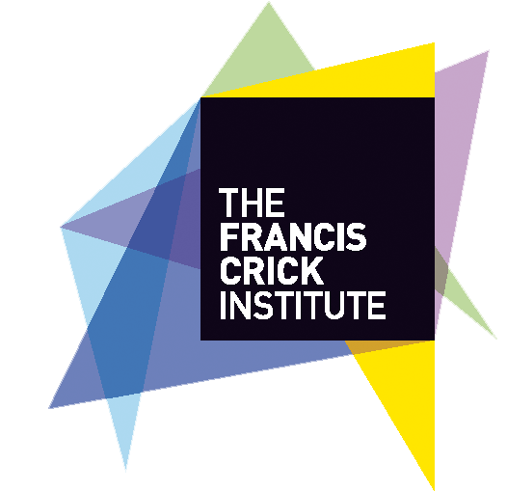
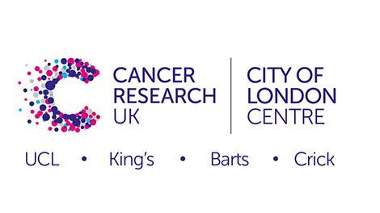

New Directions in Immuno-Oncology - Therapies and Stratification
28-30 September 2020, Francis Crick Institute, London.

Abstract Submission Form – Oral and/or Poster Presentation
To be submitted to events@crick.ac.uk by 17:00 on 20 July 2020

Abstract title

Your name | Your Institution | Your current role at your institution | Your email address

Abstract (max 250 words) must be submitted in Arial 11pt.

Please tick one of the following to confirm for which format you would like your abstract to be considered for:
Poster Presentation Only | Oral Presentation Only | Either Poster or Oral Presentation

If your oral or poster presentation is chosen for the Symposium and you wish your web/social media details to be included in the abstract booklet, please provide details below
Web address | Twitter

Abstract guidance:
- All abstracts will be reviewed by members of the Organising Committee and assigned to the appropriate session for an oral and/or poster presentation.
Preparing and Formatting an Abstract
- Abstracts can only be submitted online using the Abstract form for oral and/or poster presentations available above.
- Abstracts must be submitted in English
- No references, tables or graphics should be included in the abstract
- For authors please use this format :1st author, presenting author et al
- When using abbreviations within the body of the abstract, please spell out the name in full at first mention and follow with the abbreviation in parenthesis.
  - It is the responsibility of the author to ensure abstract text does not contain any typos or grammatical errors.
  - No changes can be made after the abstract deadline has passed.
Oral presentations
These are expected to last 10 minutes with 5 minutes Q and A; one presenter per abstract submitted
Poster presentations
Posters will be on display at the event on poster boards
As this is an interactive event, it is expected that the author of the submitted poster will register and attend the event to be available to discuss the research with fellow delegates during scheduled poster sessions
Each poster will be presented on one side of a large poster board. The maximum dimensions for your poster are A1 portrait.

