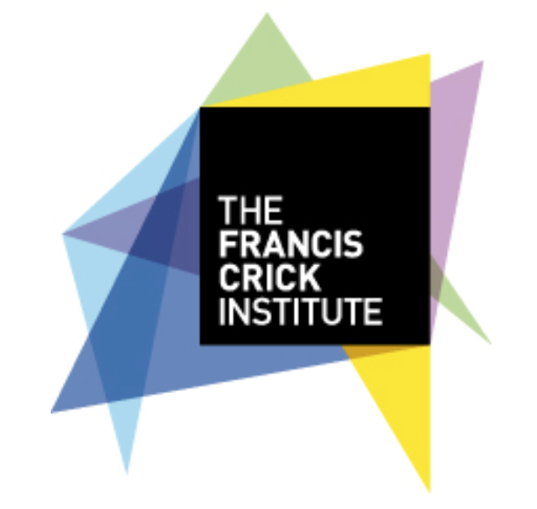
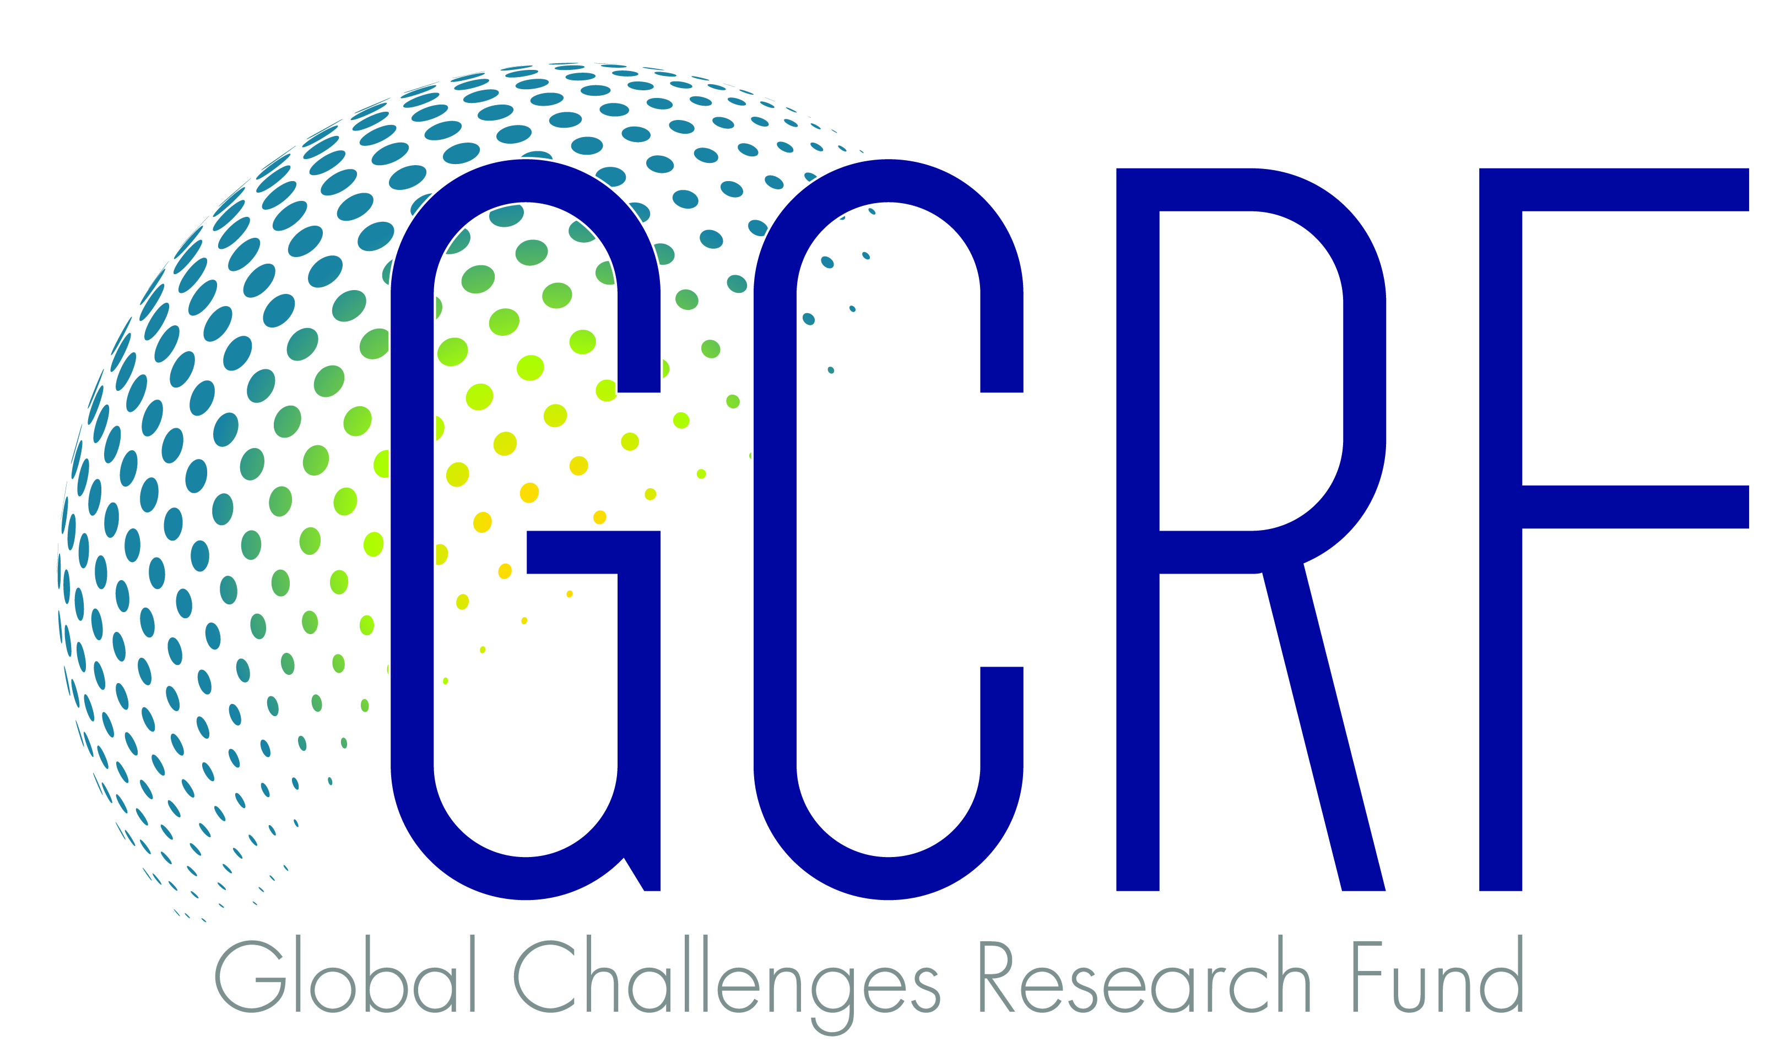

Research Methods Workshop March 7-8th 2018

MRC/UVRI Training Building
UVRI Campus
Plot 51-59 Nakiwogo Rd
Entebbe

– APPLICATION FORM –

Deadline for receipt of applications: Friday 12th January 2018 (1700 CAT)

Applications should be e-mailed to stephen.cose@mrcuganda.org

Minimum selection criteria – applicants should:

1/ Be a postdoctoral level researcher specialising in any health-related field. Those interested in infectious diseases are particularly encouraged

2/ Have a major interest in health research and wish to become an African leader in that field.

3/ Write a research protocol for a study, which is also considered feasible for the candidate within the institutional setting or through collaboration with Crick.

4/ Be fluent in written and spoken English and have good computer skills.

5/ Have support from the Supervisor/Head of Department to participate in the workshop and to develop their career in research.

IMPORTANT INFORMATION

- Please complete ALL fields

- Please respect the word/character limits allocated to certain fields

- Pictures/graphs can be copy-pasted into the relevant fields

- Please ensure that the uploaded document size does not exceed 4 MB

Q1 | CANDIDATE’S DETAILS

(a) |  | Surname: |  |  |  | Forenames:
 |  | Title (Dr, Ms, Mr): |  |  |  | Nationality:
 |  | Contact address:
 | Work tel no.: |  |  |  | Email address:
(b) |  | Current position:
 |  | Current institution & address:

(c) | Education/training (add new rows as necessary):
 | Date (mm/yy) | Degrees and  diplomas | Subject | University/Institution

(d) | Previous posts: (up to three, list most recent first)
 | Dates (dd/mm/yy) | Position and source of funding | University/Institution
(e) | Candidate’s publications (List all publications including any “submitted” or “in press”) Please separate into the categories original research, reviews and editorials, case reports. Do not include abstracts, or articles ‘in preparation’.

Q2 | RESEARCH ABSTRACT
(a) | Project title:

(b) | Outline of research project (no more than 500 words) 1 embedded item (a Figure or a Table) is permitted and will not add to the word count. Word counts will be checked and applications returned if the limit is exceeded.
 | Please list (a) The research question (i.e. hypothesis) (b) Aims that address the hypothesis (c) Brief background and relevance of the proposal (d) A research plan that addresses the aims

Q3 | MOTIVATION TO PARTICIPATE IN THIS WORKSHOP
 | Include consideration of your immediate and future career plans (300 words max.)

Q4 | STATEMENT FROM THE CANDIDATE’S SUPERVISOR OR HEAD OF DEPARTMENT IN SUPPORT OF THE APPLICATION
In the statement (max. 200 words) please include:
a) Commitment to support the applicant’s participation in the workshop and their desire to develop their career in research. The Supervisor or Head of Department should also comment on the relevance and feasiblity of the proposed study for the candidate within the institutional setting or through collaboration.

Q5 | UNDERTAKINGS and SIGNATURE
 | I agree to assist the Crick African Network at intervals to develop its monitoring and evaluation strategy by providing feedback on the workshop and subsequent development of my proposal and career
 | Candidate
 | Supervisor

